SOFTWARE REQUIREMENTS SPECIFICATION

Smart Campus Grievance &
Workflow Management System
(SCGWMS)

Prepared By | Nihita Gupta
SAP ID | 590013029
Batch | Batch-1
Course | B.Tech Computer Science Engineering
Semester | 4th Semester
Supervisor | Mr. Mritunjay Kumar

Introduction
  - Purpose
This Software Requirements Specification (SRS) document is aimed at describing the requirements of the Smart Campus Grievance & Workflow Management System
(SCGWMS). This mechanism is meant to assist the students in making complaints about the facilities of the campuses like classrooms, hostels, internet and other facilities. The system will enable the administrators to monitor, read, and address such complaints in a structured manner. The students will also be in a position to follow up the position of their grievances once they have been submitted. Through this document, there will be a clear idea of how the
system is going to work and what features it will entail. It serves as a guide that encompasses the developers, stakeholders and users in the development and use of the system.
  - Document Conventions
System: system is the Smart Campus Grievance & Workflow Management System.
User: Users are the students who submit grievances.
Administrator: admin are the authority for managing complaints.
  - Intended Audience
This document is for:
- Students
- System administrators
- Stakeholders of the institution
- Teacher in-charge

It aids both the technical and non-technical users to learn the behaviour and requirements of the system.

  - Additional Information
The Smart Campus Grievance and Workflow Management System Seeks to enhance the level of transparency and efficiency in the management of campus complaints. In present times,
complaints are dealt with by the institutions via registers, emails and informal message. This system brings in a computerized platform which documents, monitors and controls
grievances.

  - Contact Information / SRS Team Members

Field | Details
Project | Smart Campus Grievance & Workflow Management System
Developed By | Nihita Gupta
Course | B.Tech Computer Science Engineering
Semester | 4th Semester
Batch | Batch-1
Supervisor | Mr. Mritunjay Kumar

  - References
- Resources related to workflow management systems
- University course materials

Overall Description
  - Product Perspective
The Smart Campus Grievance & Workflow Management System (SCGWMS) is a web
application that will be used to handle student complaints in an easy and structured manner. The system will enable the students to make complaints regarding the facilities and services at the campus. Allow-students to submit complaints
The system will:
- Let students send complaints concerning matters at the campus.
- Grant administrators the ability to look through and handle the complaints.
- Delegation of complaints to the relevant personnel.
- Monitor the development of every complaint till it is handled.
- Keep a good record of all grievances and problems to refer to.

  - Product Functions
The main functions of the system include:
- Registration and log in to the system to enable students and administrators to safely access the system.
- Filing of complaints whereby the students are able to complain about the facilities within the campuses.
- Status tracking on complaints so that students can monitor the status of complaints submitted. Assigning the task of complaining about the matter to employees to be handled appropriately.
- Resolving some complaints and closing after the problem is resolved.
- Administrator-oriented dashboards to see the statistics of complaints and system- related activity.
- Management of complaint history to keep records of the complaints in the past to be referred to in the future.

  - User Classes and Characteristics

Role | Characteristics | Responsibilities
Student (User) | Basic computer knowledge; uses system to submit complaints | Register account, submit  complaints, track complaint status
Administrator | Authority with full access to system | View complaints, assign  complaints, change complaint status, manage users

Role | Characteristics | Responsibilities
Staff (Optional) | Responsible for solving assigned complaints | View assigned complaints, update complaint progress, mark  complaint as resolved

  - Operating Environment
The system will be working under the following environment:
- Hardware Requirements: A computer or laptop that is connected to the internet.
- Frontend Technologies: Bootstrap, CSS, JavaScript and HTML to design user interface.
- Backend Technologies: Node.js or Python (Django) to process the server-side functionality and system logic.
- Database: MongoDB or MySQL to store data on complaints, user data and system logs.
- Browser Support: The system will be compatible with the modern web browsers
which include: Google Chrome, Microsoft edge and Mozilla Firefox. The system will be used by the users via a web browser interface.

  - User Environment
Users will interact with the system through a web browser interface. The interface will include:
- A student and administration login page to get access to the system.
- A contact page where students are able to complain.
- A dashboard of complaint status where the users can monitor the status of complaints.
- A complaints management and resolution administrative control panel.
- This system must be straightforward, easy to use and have easy access by everyone using it

  - Design / Implementation Constraints
- The system must run on web browsers.
- The system should be implemented using available programming languages.
- The database must ensure data integrity.
- The system should maintain security of user information.

  - Assumptions and Dependencies
Assumptions:
- Users have internet access.
- Users have basic knowledge of web applications. Dependencies:
- Web server for hosting
- Database management system
- Authentication mechanism

Functional Requirements
  - User Authentication and Registration

Attribute | Details
Requirement ID | FR-01
Module | Authentication
Priority | HIGH
Description | Users must be able to register and log in using their college- issued credentials.

    - Action / Result

Action (Input) | Result (Output)
User enters Student ID and password (valid). | User is redirected to their dashboard.
User enters invalid credentials. | Error message is displayed: 'Invalid ID or Password.'

  - Grievance Submission

Attribute | Details
Requirement ID | FR-02
Module | Grievance Submission
Priority | HIGH
Description | A logged-in user can fill a grievance form with category, description, and attachments.

    - Action / Result

Action (Input) | Result (Output)
User selects category, writes description, submits form. | Grievance is saved with a Grievance ID and status set to 'Pending'.
User submits form with empty description. | Validation error: 'Description cannot be empty.'

  - Grievance Tracking

Attribute | Details
Requirement ID | FR-03
Module | Grievance Tracking
Priority | HIGH
Description | Students must be able to view and track the status of their submitted grievances.

    - Action / Result

Action (Input) | Result (Output)
User visits 'My Grievances' page. | List of all submitted grievances with  Grievance ID, category, date and current status is displayed.

  - Admin Grievance Management

Attribute | Details
Requirement ID | FR-04
Module | Admin Management
Priority | HIGH
Description | The administrator can view all grievances, assign them to  department staff, update their status and add resolution remarks. Admin can filter by category, department, date and status.

    - Action / Result

Action (Input) | Result (Output)
Admin logs into admin dashboard. | Dashboard shows grievances pending count, resolved count and department-wise  breakdown.

  - Escalation and Notification System

Attribute | Details
Requirement ID | FR-05
Module | Escalation & Notifications
Priority | MEDIUM

Attribute | Details
Description | Grievances that are not resolved within the defined SLA period must be automatically escalated to authorities. The system must check grievance age daily.

    - Action / Result

Action (Input) | Result (Output)
Grievance is not resolved within 3 days. | Auto-escalated to Department Head. Email alert sent to both Department Head and student.

Non-Functional Requirements
  - Performance Requirements
- The system must load any page within 3 seconds on a broadband connection.
- The system must support at least 500 concurrent users without performance degradation.
- Database queries must respond within 1 second for standard operations.
  - Safety Requirements
- The system must perform automatic daily database backups. In case of failure, data loss must not exceed 24 hours.
- All uploaded files must be scanned for viruses or malicious content before storage.
- The system must have a disaster recovery plan that can restore services within 4 hours of a major failure.
- No critical student or personal data should be permanently deleted without a 30-day soft-delete period.
  - Security Requirements
- Any transmission of data should be encrypted with HTTPS.
- This should be done by having the system apply the role-based access control
(RBAC) to prevent users having access to data that is not related to their position.
- Two-Factor Authentication protection should be implemented on the Admin accounts.
- There should be a maximum of 5 failed attempts on logins after which the account is temporarily disabled (locked) 15 minutes.

  - Software Quality Attributes

Quality Attribute | Description
Usability | The user interface must be simple enough for first-time users (students) to submit a grievance without any training or manual.
Reliability | The system must function correctly under normal and peak load conditions, with a minimum uptime of 99.5%.
Maintainability | The source code must be well-documented and follow MVC architecture to allow easy updates and bug fixes.
Portability | The system must work on all major operating systems (Windows, macOS, Linux) and modern web browsers without modification.
Scalability | The system must be designed to handle increased load as the number of students and grievances grows over time.

  - Project Documentation
The preparation of the Software Requirements Specification (SRS) document must be made prior to the system development commencement. This will be clearly stated in the document with regard to the system requirements and functionalities.
Technical documentation must also be done properly after the system has been developed. This will entail API documentation, database structure and a deployment guide on how to set up the system.
During the development process, all the source code should be accompanied by clear
comments and level documentation of the source code so that it can be easily comprehended and maintained.
Students and administrators should also have a separate user manual that will aid them to know how to use the system appropriately
  - User Documentation
- To help students learn to use the system, a Student User Guide ought to be included that shows how the students can be able to register, log in, make complaints, and
monitor their complaints.
- An Admin User Guide ought to demonstrate how administrators can deal with
grievances, administrators can administer user accounts, and administrators can issue system reports.
- The login page should have a quick-start help card so that the users can quickly learn the usage of the system.

- The system portal should also have a FAQ (Frequently Asked Questions) section to reply to simple questions and assist users in resolving simple problems.

ER Diagram
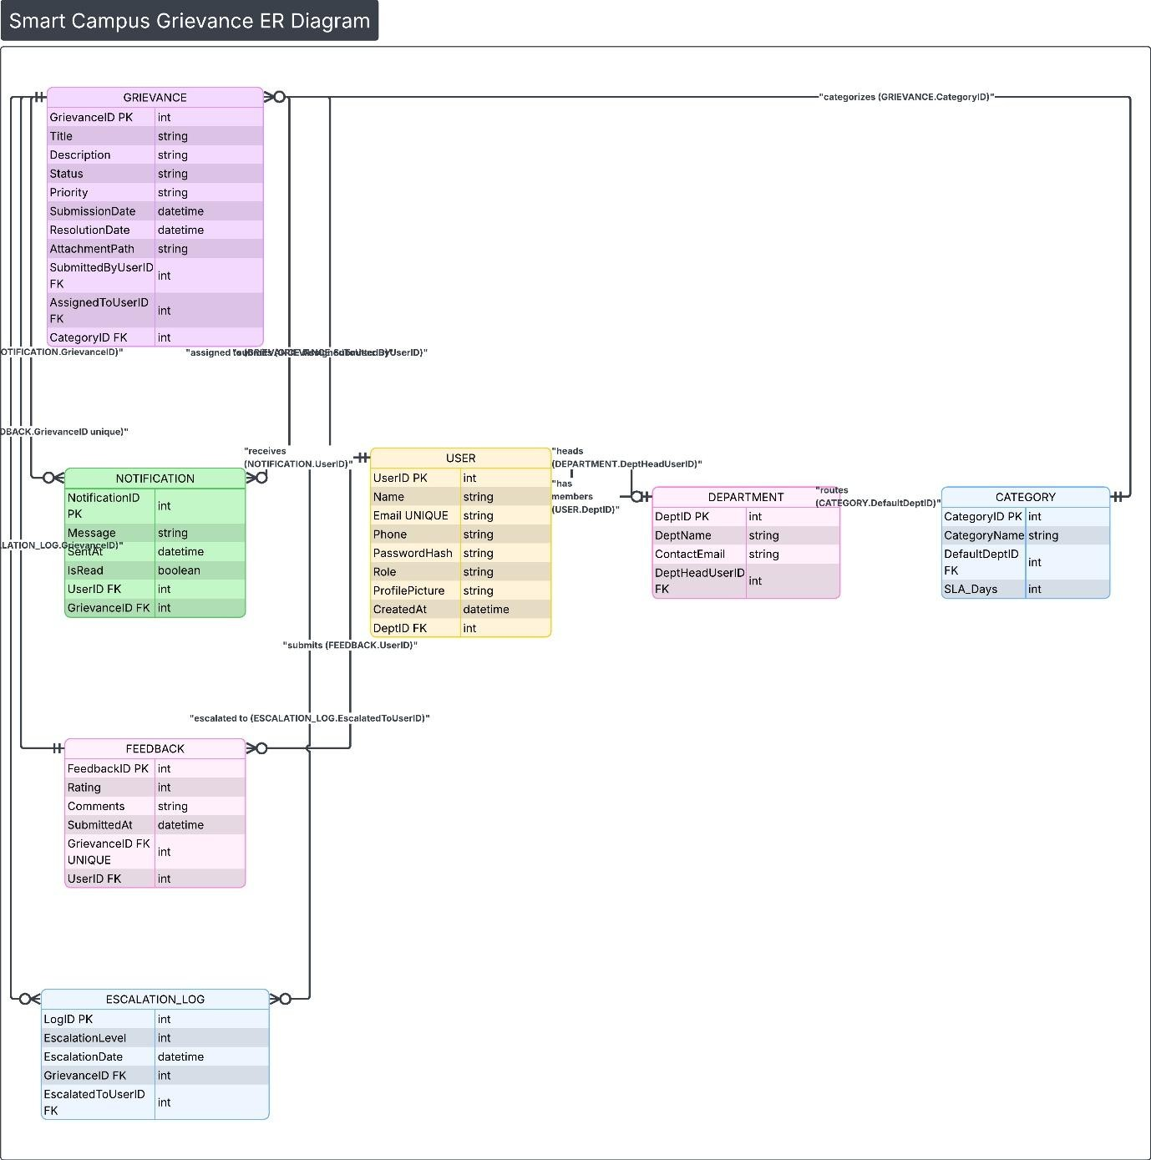

- Data Flow Diagram (DFD)
  - Context Level DFD (Level 0)
Context Diagram (Level 0 DFD) presents the SCGWMS as the isolated process that interacts with all the external entities. It represents the topmost perspective of the system
External Entities:
- Student/Faculty User: Sends out grievances, gets notifications and status updates.
- Admin / Department Head: Administrator: strides and addresses grievances, preparer of reports.
- Email Server (SMTP): Sends notification emails to users.
- College Database: It contains user authentication information (student/faculty records).
Data Flows in Context Diagram:

From | To | Data Flow
Student/Faculty | SCGWMS | Login credentials, Grievance form data, Feedback
SCGWMS | Student/Faculty | Dashboard view, Grievance status, Notifications
Admin | SCGWMS | Grievance assignment, Status updates, Report requests
SCGWMS | Admin | Grievance list, Analytics reports, Escalation alerts
SCGWMS | Email Server | Email notification request
College Database | SCGWMS | User authentication data

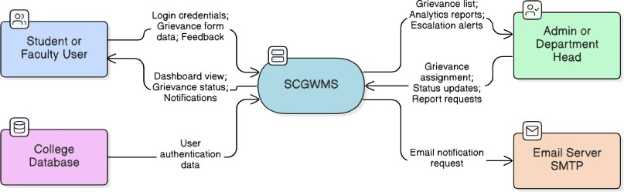

  - Level 1 DFD
The Level 1 DFD breaks down the SCGWMS into its major sub-processes. The following processes are identified:

Process No. | Process Name | Description
1.0 | Authenticate User | Validates user credentials against the college database. Returns access token or error message.
2.0 | Manage Grievance | Handles grievance submission, editing, and viewing for students. Creates a new grievance record in the database.
3.0 | Process & Assign Grievance | Admin process: views pending grievances, filters them, and assigns to appropriate staff. Updates grievance status.
4.0 | Resolve Grievance | Staff marks grievances as resolved, adds resolution notes. System triggers notification to student.
5.0 | Send Notifications | Triggered after any status change. Sends email alerts to relevant users via the SMTP Email Server.
6.0 | Generate Reports | Admin requests reports. System fetches and aggregates grievance data and returns graphical statistics.

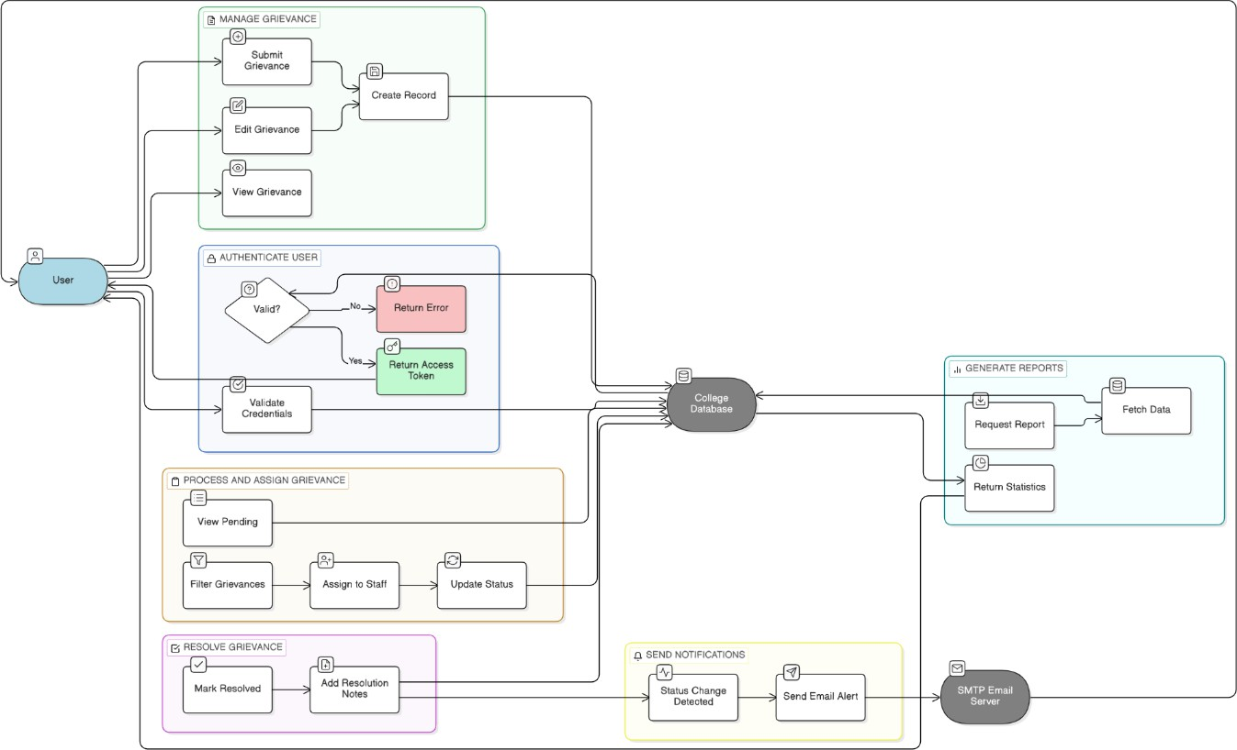

  - Level 2 DFD (For Process 2.0 - Manage Grievance)
This level further decomposes Process 2.0 (Manage Grievance):

Process 2.0 (Manage Grievance) is further sub-divided into smaller processes at this level:
- Process 2.1- Validate Form Input: The system will verify that all the necessary fields in the complaint form are duly filled properly and the attachment that is uploaded is a valid one.
- Process 2.2 -Store Grievance: Once validated, the system records the prepared grievance information as Grievance database with status of pending.
- Process 2.3 -Create Grievance ID: The system creates a unique Grievance ID (such as: GRV-2026-001) and presents it to the user as a reference in the future.
- Process 2.4 - Retrieve Grievance List - The system reads all the grievance posted by the user who is currently logged in and displays it

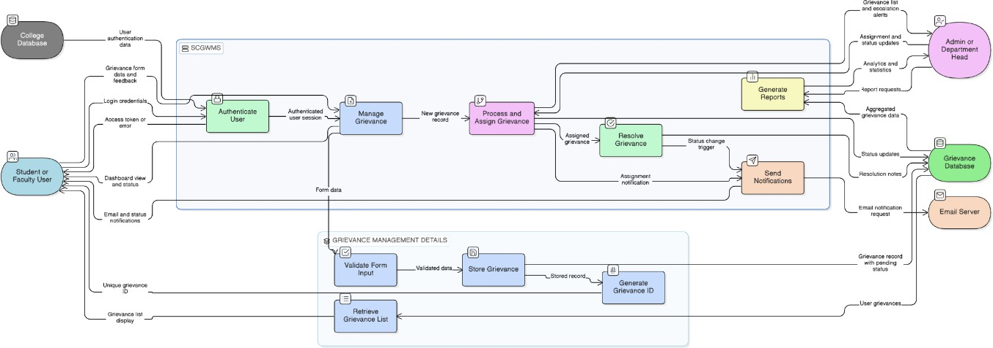

  - Description of Each Process
Process 1.0 – Authenticate User:
This is something that deals with user login. The login form sends the User ID and password to it and compares it to the College Database. When the information is accurate, the system will generate a user session and direct the user to the dashboard. In case of misinformation in the details the system displays an error message.
Process 2.0 – Manage Grievance:
It is the primary process applied by students. It enables the students to place and read their complaints. The system authenticates the form information, stores the complaint in the
Grievance Data Store and also enables the students to access their previous grievances. Process 3.0 Processes and Assign Grievance:
During this procedure, all the complaints raised by the students are examined by the
administer. The admin will be able to sort complaints according to the category or date, then allocate them to the right staff member. The staff assignment will subsequently be stored in the Grievance Data Store.
Process 4.0 – Resolve Grievance:
This process is used by the staff member that is assigned to the grievance to change the status of the complaint to resolved. They are also able to write comments or information about the way the problem has been resolved. When the status is updated it initiates the notification
process.
Process 5.0 – Send Notifications:
This is an automatic process which is executed in case of change in the grievance status. It connects the contact information of the user in the User Data Store and mails an email
notification via the Email Server (SMTP). Process 6.0 – Generate Reports:
The admin uses this process to come up with reports regarding grievances. The system
gathers the data available out of the Grievance Data Store, processes them (complaints by category, department, or status), and represents the findings as charts or tables.

Use Case Diagram
  - Use Case Diagram Description
The Use Case Diagram of the Smart Campus Grievance and Workflow Management System (SCGWMS) demonstrate the interaction of various users with the system and the actions that various users are allowed to do.
Actors:
Student: This is the primary user of the system who will be able to file grievances and monitor the way their complaints are handled.
Faculty/Staff: They are able to make grievances and also to respond to complaints assigned to them.
Admin/Registrar: They will take care of the entire system. They are able to see and manage any grievance, control users as well as produce reports. Their access to the system is
complete.
Department Head: They check and supervise grievances in their department and make sure that they are addressed.
Email Server: This is an external system, which automatically forwards notification email messages to the users in cases of updates regarding grievances
Use Cases:

Use Case ID | Use Case Name | Actor(s)
UC-01 | Register / Login | Student, Faculty, Admin
UC-02 | Submit Grievance | Student, Faculty
UC-03 | Track Grievance Status | Student, Faculty
UC-04 | View My Grievances | Student, Faculty
UC-05 | Assign Grievance to Staff | Admin, Department Head
UC-06 | Resolve Grievance | Staff, Admin
UC-07 | Escalate Grievance | System (Auto), Admin
UC-08 | Send Email Notification | Email Server (Auto)
UC-09 | Submit Feedback | Student

UC-10 | Generate Reports | Admin
UC-11 | Manage Users and Categories | Admin

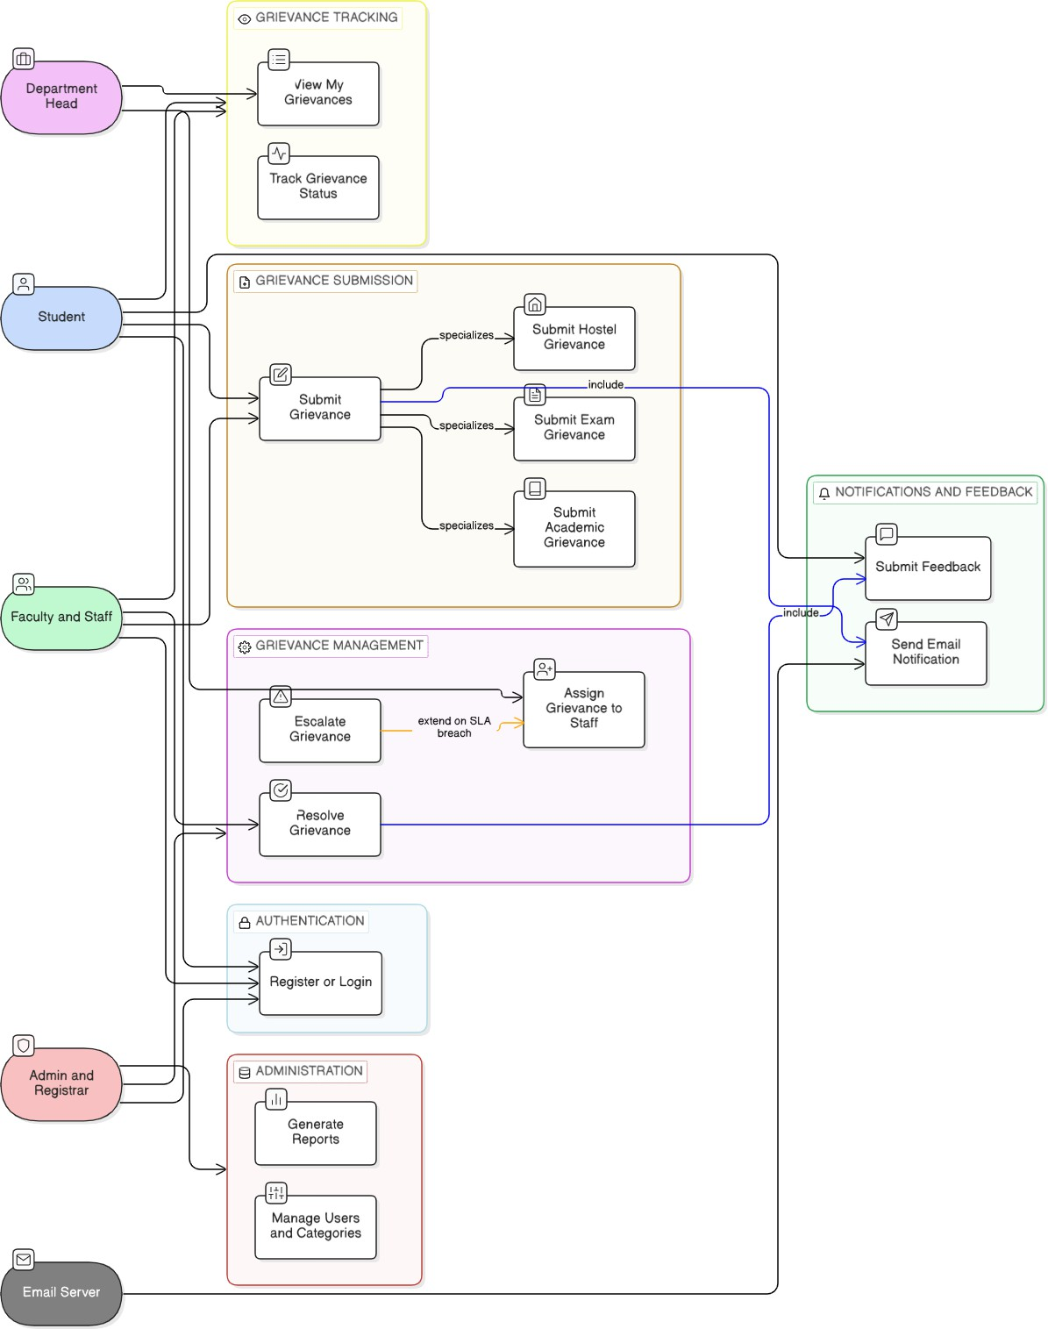

Conclusion
This software Requirement Specification (SRS) document describes the design and requirement of the Smart Campus Grievance and Workflow Management System
(SCGWMS). The key arguments of this paper are:
The system aims at addressing real issues encountered by students and faculty in learning institutions in reporting campus matters.
The key functional requirements of the system are well stated in order to describe the working of the system.
New requirements will be considered to make the system safe, sound and efficient.
The ER Diagram depicts the key objects within the system and their relation towards one another.
The DFD (Data Flow Diagram) describes the flow of data within various processes within the system.
The Use Case Diagram displays the interactions between the various users and the system.
In general, the SCGWMS will assist in the better management of the grievance process in the institutions making it more visible, systematized, and quicker to both students and the
administrators.

